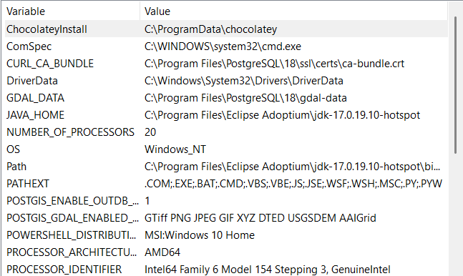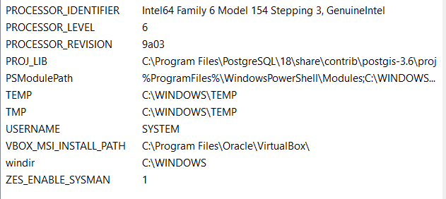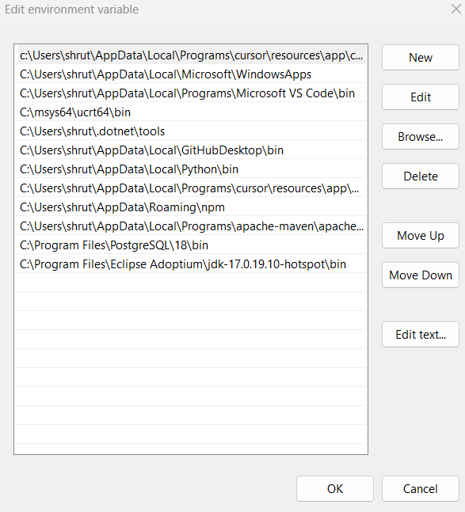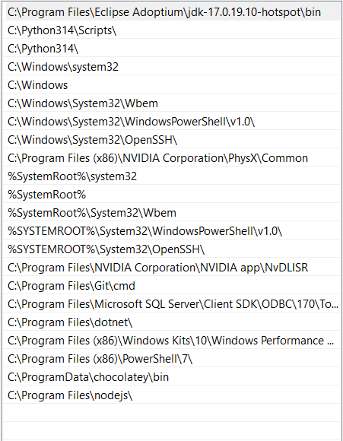

For sql issue
4. Check for PATHEXT issues
Run
echo %PATHEXT%
You should see something like
.COM;.EXE;.BAT;.CMD;...
If .EXE is missing, Windows won't automatically recognize .exe files by name.

